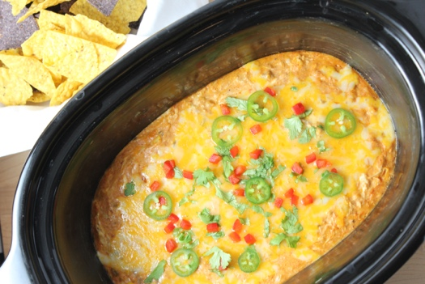
Chicken Enchilada Dip: Oven Baked or Slow Cooker
Tina Verrelli, 2019

One of the most requested recipes I make on QVC! It’s a family favorite at home too! Very flavorful, but not super spicy. It’s so easy to make - shredding the chicken with my hand mixer or stand mixer makes this recipe so easy! Take a shortcut by using rotisserie chicken.

Makes: 6-8 servings

Ingredients:
2 cups shredded chicken
8 ounces cream cheese, cut into 8 cubes, softened
1 (19-ounce) can red enchilada sauce
1 (4-ounce) can diced green chilies
½ cup frozen corn, thawed
1 tablespoon taco seasoning
Juice of half a lime
3 cups shredded pepper jack, colby jack or cheddar cheese – divided

Optional Toppings:
Diced red bell pepper
Sliced jalapenos
Fresh Cilantro

Directions:

Tip: Shred moist, warm chicken with your hand mixer using your traditional beaters or in your stand mixer using your flat beater.

Mix together shredded chicken, cream cheese, enchilada sauce, green chilies, corn, taco seasoning, lime juice and 2 cups of the shredded cheese.

Oven Bake: Preheat oven to 350 degrees. Spread mixture in baking dish and top with remaining cheese. Bake until warm and bubbly.

Slow Cooker: Spread mixture in slow cooker. Cook on high for 1 hour. Give a stir. Sprinkle remaining cheese on top and cook for 20 minutes more on low.

Serve with Tortilla Chips

